Customer Shopping Behavior Analysis
- Project Overview
This project analyzes customer shopping behavior using transactional data from 3900 purchases across various product categories. The goal is to uncover insights into spending patterns, customer segments, product preferences, and subscription behavior to guide strategic business decisions.
- Dataset Summary
- Rows: 3900
- Columns: 18
- Key Features:
  - Customer Demographics (Age, Gender, Location, Subscription Status)
  - Purchase Details (Item Purchased, Category, Purchase Amount, Size, Color)
  - Shopping Behavior (Season, Discount Applied, Promo Code Used, Previous Purchases, Frequency of purchases, Review Rating, Shipping Type)
- Missing data: 37 values in review rating column

- Exploratory Data Analysis
We began with data preparation and cleaning in Python:
Data Loading: Imported dataset using pandas.
- Initial Exploration: Used data.head(), data.info() to get a basic understanding of data, and data.describe() to get summary statistics.
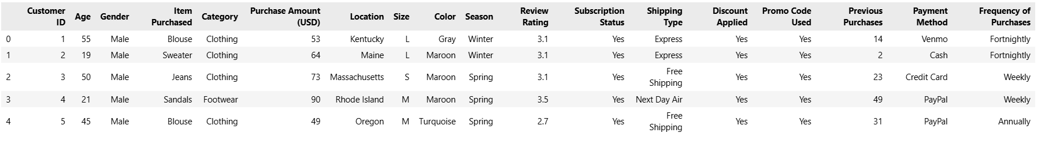
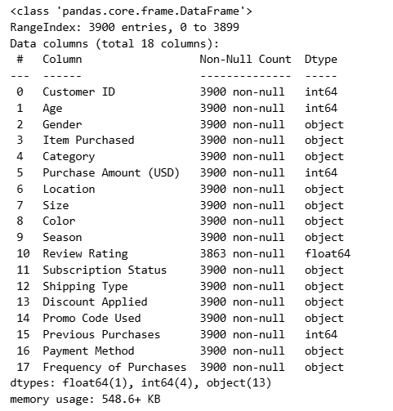
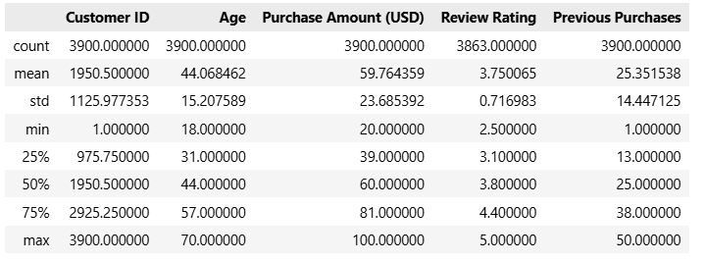

- Missing Data Handling: Checked for null values and imputed missing values in the review rating column using the median rating of each product category.
- Column Standardization: Renamed columns to snake case for better readability and documentation.
- Feature Engineering:
Created age_group column by binning customer ages.
Created purchase_frequency_days column from frequency of purchases data.
Data Consistency Check: Verified discount_applied and promo_code_used were redundant; dropped promo_code used.
Database Integration: Connected Python script to SQL Server and loaded the cleaned dataframe into database of SQL Server.
- Data Analysis using SQL
We performed structured analysis on SQL Server to answer key business questions:
- Revenue by Gender: Wrote SQL code to display revenue made by each gender.

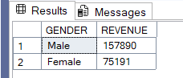

- High Spending Discount Users: Identified customers who used discounts but still spent above the average purchase amount.

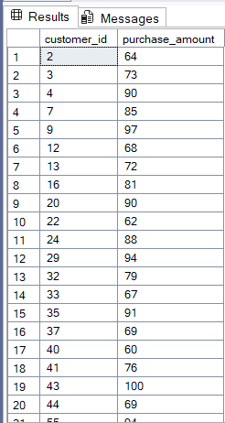
- Products with high average review rating: Identified top 5 products with more than average review rating.

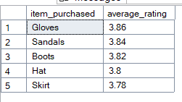

- Spending difference between Standard and Express Shipping: compared the average purchase amount between standard and Express Shipping
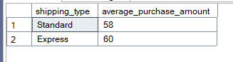

- Spend difference between subscribed and non-subscribers: compared the average spend and total revenue between subscribed and non-subscribers.

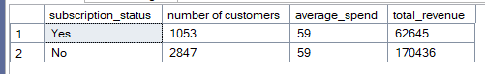

- Products with highest percentage of discounts applied:

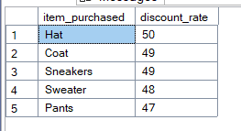

- Customer Segmentation: Segmented customers into four groups by age. Young adult, adult, middle-aged, Senior

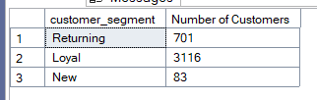

- Highest selling products within each category: Identified top 3 selling products in each category.

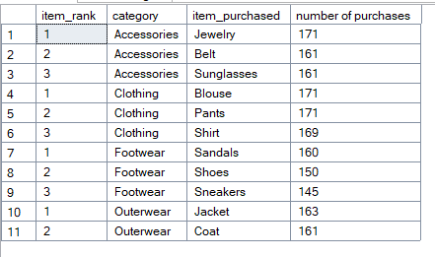

- Repeated customers with subscription status: Got the count of subscription status for customers with more than 5 orders.

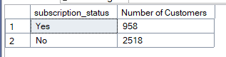

- Revenue distribution among each age group: Displayed the revenue generated by each age group.

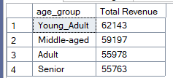
- Power BI Dashboard: Created Power BI dashboard to visualize the insights from our analysis

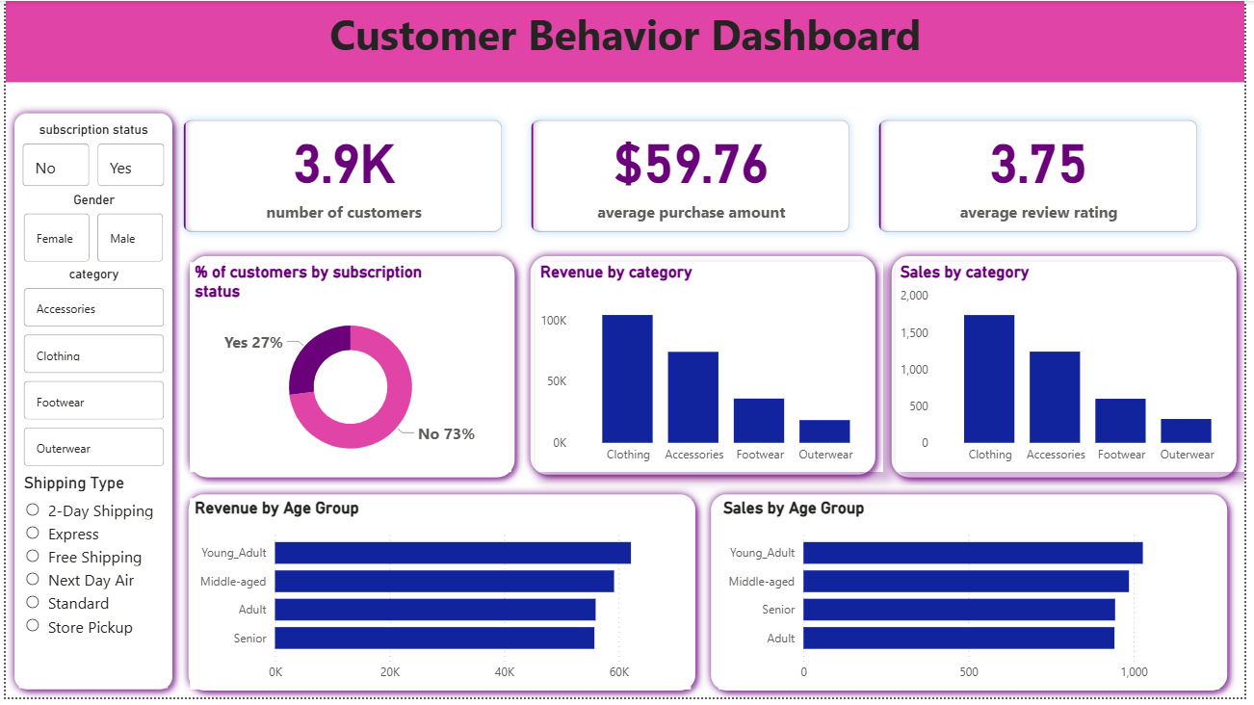

- Business Recommendations:
- Boost Subscriptions: Promote exclusive benefits for subscribers.
- Customer Loyalty Program: Reward repeat buyers to move them into the “Loyal” Segment.
- Review Discount Policy: Balance sales boosts with margin control.
- Product Positioning: Highlight top rated and best-selling products in campaigns.
- Target Marketing: Focus efforts on high-revenue age groups and express-shipping users.

